**Mr. Visca’s: Calculus**

**Chpt 5 – Day 3.5: Integrate w U-Substitution**

**Integrate by U-Substitution**

1. set appropriate expression = _______________

2. find __________________________________, and solve it for dx  
3. substitute both ______________________ into integral and solve with u

4. don't forget to put _______________________________ back in for u

OR

do _______________________ (w upper and lower bounds)

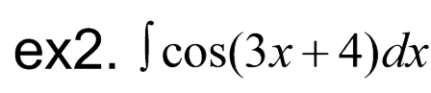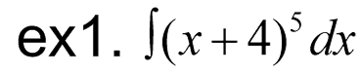

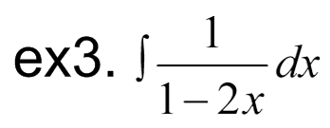

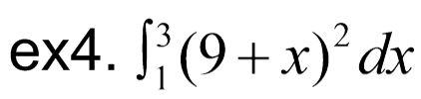

***WHAT!?!? This looks way to complicated!!!***

RELAX...the help to you seek is literally right in front of your face...no not, me. It's in the problem.

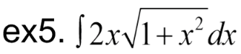

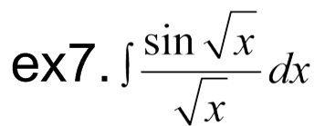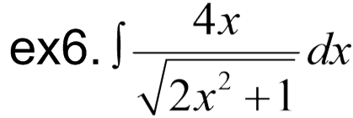

**HOMEWORK:**

5-3.5 U substitution worksheet